Mar 25, 2019

Servo Motor cONTROLLER

นางสาวกมลชนก วิชชุตารัช รหัส 5910610517| LE484 Micro APP | Supachai Vorapojpisut

Second project is to create a firmware for a servo motor controller supporting multiple interfaces.

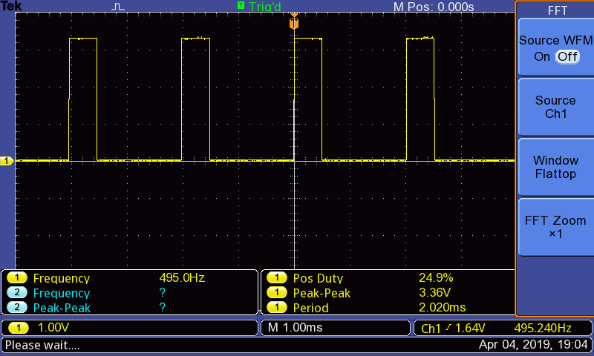

| Task | NOTE | DONE |
| --- | --- | --- |
| Create an MDK-ARM project with STM32CubeMX   * Enable SYS > Serial Wire Viewer * HCLK at 168 MHz * EXTI for SW1 * GPIO input for DIPSW1-6 * PDM output for pin PA8 * Input capture for pin PB11 * Analog output for pin PA4 * Analog input for pin PB0 * UART TX/RX pins for pins PD8/PD9 |  |  |
| Write a function for DIPSW1 to generate PDM (pulse duration modulation) signal   * Use pin PA8 (TIM1 channel 1) * Generate frequency 500 Hz |  |  |
| Write a function for DIPSW2 to capture pulse width   * Use pin PB11 (TIM2 channel 4) * Return value with 1 μsec resolution |  |  |
| Write a function for DIPSW3 to generate voltage   * Use pin PA4 (DAC_OUT1) * Generate 1.5 Volt |  |  |
| Write a function for DIPSW4 to read voltage   * Use pin PB0 (ADC1/2 channel 8) * Return value in voltage |  |  |
| Write a function for DIPSW5 to send UART messages   * Use pin PD8 (USART3_TX) * Configure 9600,8,n,1 * Use interrupt-driven HAL functions * Print “Hello, world” text |  |  |
| Write a function for DIPSW6 to receive UART messages   * Use pin PD9 (USART3_RX) * Configure 9600,8,n,1 * Use interrupt-driven HAL functions * Return number of received characters |  |  |
| Write code for main loop   * Use SW1 status to execute functions * Call functions based on status of DIPSW1-6 * Print returned value |  |  |